Coherent Consciousness, Reduced Randomness, September 11, 2001

Roger Nelson

Director, Global Consciousness Project, Princeton, NJ
Correspondence may be directed to rdnelson@princeton.edu

Abstract

The Global Consciousness Project (GCP) is an international collaboration of researchers with an interest in the possibility that there may be detectable effects of consciousness interacting with the environment. Here, we describe the behavior of the GCP's network of REG devices called "eggs" placed around the world as they responded during various periods of time around September 11 2001. These eggs generate random data continuously and send it for archiving and analysis to a dedicated server in Princeton, New Jersey. We analyze the data to determine whether the normally random array of values shows structure correlated with global events. Our intent is to discover whether there is evidence for an anomalous interaction driving the eggs to non-random behavior. In a metaphoric sense, we are looking for evidence of a global consciousness that might react to events with deep meaning. The whole world reeled in disbelief and horror as the news of the terrorist attack and the unspeakable tragedy unfolded. The GCP network of REGs registered an unmistakable response that appears to be correlated with the surge of shared thoughts and emotions. Three formal analyses were made, testing hypotheses based on standardized procedures for making predictions and performing a statistical evaluation. In addition, several exploratory analyses, including work by four independent analysts or teams, have addressed the context of several days preceding and following the major events. Taken together, the results indicate a substantial increment of structure in the nominally random data sequences associated with the events. No ordinary sources such as electrical disturbances or unusual cell phone activity are viable candidates to explain the effects on the GCP network. Although we cannot claim direct evidence for it, the most likely interpretation is that the anomalous structure is somehow related to the unusually coherent and emotional focus of attention on the events.

Introduction

On September 11, 2001, beginning at about 8:45 in the morning, a series of terrorist attacks destroyed the twin towers of the World Trade Center (WTC) and severely damaged the Pentagon. The disaster was so great that two days later, we had only guesses about how many thousands of people perished when the WTC towers collapsed. Commercial airliners were hijacked and flown directly into the three buildings. The first crashed into the North tower at 8:45, and about 18 minutes later the second airliner hit the South tower. At about 9:40, a third airliner crashed into the Pentagon. At about 9:58, the South tower collapsed, followed by the North tower at 10:28.

Without question, these events and the powerful reactions around the world qualified as a "global event" for the Global Consciousness Project (GCP), an international collaboration involving researchers from several institutions and countries. The purpose of the GCP is to explore whether objective measurement may reveal correlations between inferred special states of consciousness on a global scale with the behavior of physical devices. The project builds on excellent experiments conducted over the past 35 years at a number of laboratories, demonstrating that human consciousness interacts with true random event generators (REGs), as indicated by non-random patterns that are correlated with intentional, mental efforts (Radin and Nelson, 1989). For example, the long-term experimental program of the Princeton Engineering Anomalies Research group includes work with unselected participants attempting to change the distribution of numbers produced by a true random event generator in exquisitely controlled experiments. The results show a tiny but significant correlation with the participants' assigned intentions (Jahn, et al., 1997). The replicated demonstrations of anomalous mind/machine interactions clearly show that a broader examination of this phenomenon is warranted, and the research continues in a number of laboratories. Variations on the theme include taking the REG technology into the field to see whether group interactions might affect the random data, (Nelson, et al., 1996, 1998a). In related work, prior to the Global Consciousness Project, an array of REG devices in Europe and the US showed non-random activity during widely shared experiences of deeply engaging events. For example, the funeral ceremonies for Princess Diana, and the international Winter Olympics in Nagano, Japan, created shared emotions and a coherence of consciousness that appeared to be correlated with structure in the otherwise random data (Nelson, et al., 1998b). These experiments were prototypes for the Global Consciousness Project. In the fully developed project, a world-spanning network of some 40 host sites collect data continuously and send it to a central server in Princeton, NJ, via the Internet. The system is designed to create a continuous record of nominally random data over months and years, gathered from a wide distribution of locations. Its purpose is to document and display any subtle, but direct effects of our collective consciousness reacting to global events. The research hypothesis predicts the appearance of coherence and structure in the globally distributed data collected during major events in the world. The events that comprise the sample of test cases share a common feature, namely, that they powerfully engage our attention, and draw us in large numbers into a common focus.

Although I take responsibility for the descriptions in this paper, I will use collective pronouns to represent the collaborative nature of this work. I also want to acknowledge the fact that some of the terminology and images in these descriptions are convenient metaphors rather than scientific entities. For example, I like the notion of global consciousness, but it is clear that at this point the idea is an aesthetic speculation. We do not have solid grounds to claim that the statistics and graphs representing the data prove the existence of a global consciousness. On the other hand, we do have strong evidence of anomalous structure in what should be random data, and clear correlations of these unexplained departures from expectation with well-defined events that are of special importance to people.

Method

Because this is an unusual and relatively complex experiment, the research methodology requires a brief introduction. The GCP Web site presents greater depth of description and discussion (Nelson, 1998c), and an article published in the professional Journal of Parapsychology details the experimental procedures and summarizes the first two years of GCP results (Nelson, 2001a).

Data acquisition

Understanding the methodology requires a clear picture of the physical data-acquisition system. At each of a growing number (about 40 in late 2001) of host sites around the world, a well-qualified random source (REG or RNG)* is attached to a computer running custom software to collect data continuously at the rate of one 200-bit trial per second. This local system is referred to as an "egg." The software regularly sends time-stamped, checksum-qualified data packets (each containing 5 min of data) to a server in Princeton. We assume that the eggs are synchronized to the second, although this is not always true for all eggs. Any mis-synchronization is expected to have a conservative influence in our standard analyses. The server runs a program called the basket to manage the archival storage of the data. Other programs on the server monitor the status of the network and do automatic analytical processing of the data. The results of these programs and processing scripts are used to create up-to-date pages on the GCP Web site, providing public access to the complete history of the project's results. The raw data are also made available for download by those interested in conducting their own assessments of the data or checking our analyses. With 40 eggs running, there are well over 3 million trials generated each day, and the complete database at this time occupies approximately 3 gigabytes of storage in a highly compressed form. Each day's data are stored in a single file with a header that provides complete identifying information, followed by the trial outcomes (sums of 200 bits) for each egg and each second.

Analysis

The database consists of a large and continuously growing matrix of trials, each of which has an expected mean of 100 and expected standard deviation of 7.071. Deviations from the expected mean can be converted directly to (0,1) normally distributed Z-scores. Assuming N eggs in the network, there will be N Z-scores for each second, and these can be combined across eggs using the Stouffer method (Z_{s}=ΣZ_{i}/√N) to form a single Z-score representing the composite deviation of the mean at any given moment. Such a composite Z-score can be used as a basic element in the measure of an anomalous effect on the data by accumulating the second-by-second Z-scores generated during the event of interest. If desired, the same procedures can be applied to blocked data created by taking the mean over a block of time for each egg.

The hypothesis for REG experiments in general and for the EGG project in particular is that the mean value of the nominally random numbers will be shifted, in other words, that the output of the REG device will not be random as expected but will show a bias that is correlated with the putative source of influence. In some experiments (in the lab), an intention is assigned to shift the mean high or low, but in the field experiments, including the GCP, there is no specified intention. Therefore, a significant deviation of the mean in either direction away from what is expected qualifies as anomalous and interesting. The standard analytical procedure uses squared Stouffer Z-scores, which are Chi-square distributed, and specifies a positive accumulation, that is, we declare an expectation that the eggs' output will tend to show increased deviations from expectation, and test this by a one-tailed Chi-square accumulation. The formal hypothesis is defined in a prediction registry and specifies the period of time, the resolution (usually seconds, sometimes blocks of 1 min or 15 min), a confidence level, and any special requirements, e.g., signal averaging across time zones. The standard analysis described here is used unless another procedure is defined a priori for the registered prediction.

Procedure

The procedural steps in the analysis are: (a) normalizing the deviations to Z-scores, (b) combining these across eggs as a Stouffer Z-score, (c) squaring and summing the these Z-scores, and (d) comparing the overall result against its proper theoretical distribution, which is the Chi-square. There are a number of reasons why this method is used, but the important ones are: (a) All the procedures are well understood and widely used in statistics, (b) normalization is straightforward and based on a well-characterized mean and standard deviation,* (c) Chi-square values are additive, so the results from separate eggs or minutes or occasions can easily be combined to give an overall picture, and (d) the analysis represents the basic idea that the eggs will exhibit a degree of correlated behavior if they somehow respond to events in the world.

There are a number of alternative methods that might be defined. For example, we could use the sum of squared Z-scores across the N eggs for each second. This would represent the total unsigned deviation across eggs as a Chi-square-distributed quantity with N degrees of freedom. This measure obviously would give a different perspective from the composite Stouffer Z-score, and would have a similar focus to an examination of variance among the eggs. Another reasonable measure would look at the inter-egg correlations without reference to any particular events, or assess the degree of autocorrelation in the data, predicting an increase over expectation as a representation of the general hypothesis. Although various alternative methods have been explored, the vast majority of formal analyses specify the composite Z procedure first described, and most of the discussion here is based on that procedure.

The primary focus of the GCP analysis is thus on tests for anomalous shifts of the mean during periods of time specified in formal predictions. This addresses the question whether there is a tendency for the composite of the trial values across the eggs to reveal increased, correlated deviation from expectation during the specified times. In other words, it tests whether there is unusual consistency in the behavior of the eggs moment by moment over the period of interest. As noted, the hypothesis is posed as a one-tailed prediction, and decreased Chi-squares, even if significant, are not taken as evidence for the hypothesis. The theoretical expectation as a comparison standard is itself tested by examining the distribution of calibration data and by examining the results of a resampling procedure in which segments of the same size as the "active" segment are drawn randomly from "non-active" data to create an empirical distribution of "chance" Chi-squares against which the actual Chi-square can be compared. (Nelson, et al., 1998a)

Predictions

The tests for the overall GCP hypothesis depend on a Prediction Registry to establish the timing and analysis parameters for each event. This time-stamped registry is available for public inspection on the GCP Web site. Because we often cannot identify relevant events before their occurrence, we use categorical specifications to help select a reasonable sample of cases to represent the hypothesis. On the basis of prior experience, we postulate broadly engaging, emotionally salient events and situations as the conditions that tend to be correlated with anomalous and significant deviations in the REG datastreams. We set the criteria for global events restrictively, to identify very few occasions with broad scope and impact for a large number of people around the world. Each prediction identifies the period of time during which a deviation is expected in the data, and it provides the information needed for analysis. It may be helpful to note that each formal prediction is in some sense a new "experiment," so that the full database may be thought of as a large number of replications of a simple experiment.

There are three distinct categories for predictions. In some cases, they address known events, such as New Years Eve celebrations and other widely observed holidays, and certain globally interesting scheduled events, such as World Cup Soccer and the Olympics. Also known ahead of time, but with no regular schedule or repetition, are widely publicized ceremonies, such as the Princess Diana and Mother Teresa funerals. In this category we also may place some unusual cosmic events, such as major conjunctions, comets, and solar eclipses. Finally, there is a large category of unpredictable events, such as major earthquakes, the fall of the Berlin wall, the assassination of Israeli Prime Minister Rabin, the detonation of atomic weapons in India and Pakistan, or the terrorist attacks of September 11, 2001, that gather worldwide attention. The times we use for archiving the data, and hence for the predictions and analyses, are registered unambiguously in coordinated universal time (UTC or GMT).

A major source of predictions is inevitably the international news services such as CNN and BBC. The first report of a major story with global scope is readily identified, and the timing of the event is usually available from the reported story. Relatively local events may also be considered for predictions if they involve powerful engagement of many people in some part of the world. Obviously, we cannot discover or assess all possible global events, so the selection is arbitrary and constitutes a fixed sample from an indefinitely large population. A prediction may, in some cases, be segmented into two aspects, one referring to the actual event and one that looks to the developing world consciousness of the event. The first might be envisioned as representing a "psychic" reaction that would occur only if there were something like an independent global consciousness, or alternatively, as a widespread, immediate effect of an intense local reaction. The second type represents a more ordinary accumulation of engagement on a conscious level of large numbers of people because of media coverage.

Controls

Control data are needed to establish the viability of the statistical results. Because predictions for the GCP are situation dependent, we need specially designed procedures to ensure that the statistical characterizations of the complex array of data are valid. There are several components in the control procedures. We begin with quality-controlled equipment design, including a logical XOR that guarantees zero bias of the mean. In the simplest form, the logical XOR compares the random sequence with an alternating 1,0 sequence and registers each match as a "hit," thus eliminating, to first order, any spurious, physically induced bias. The design is then empirically tested by thorough device calibration, and finally, resampling procedures are used to examine the distribution of parameters in the actual data. See Nelson et al. (1998a) for more detail and examples of the resampling procedure. We have recently added another type of control analysis, based on a complete clone of the GCP database with all trial values replaced by values created from a high-quality pseudo-random algorithm. Details are beyond the scope of this article, but the control analysis essentially duplicates the formal analysis using the pseudo-random database. Although a single comparison of active and pseudo results is not by itself an adequate control procedure, the overall results combined across all formally defined events can provide a sufficient sample. The combined force of these efforts ensures that the GCP data meet rigorous standards and that the active subsets subjected to hypothesis testing are correctly evaluated against expectations established by theory and resampling of appropriate control and calibration data.

Results

The introduction and the description of methodology should make it clear that the tragedies of September 11, 2001 constitute an obvious global event that should, according to the general hypothesis, affect the GCP network of eggs, resulting in departures from expectation in the corresponding data. Two formal predictions were made for the major events on the 11th and one for an associated event on the 14th. There are some less directly associated events later, but we will focus on these three examples, plus some contextual analyses that are helpful for interpretations.

For the cases defined by the formally established hypotheses in the prediction registry, the standard analysis procedure yields an inferential statistic from the total Chi-square for the data in the prescribed period of time, as described previously. The relative consistency of anomalous effects can be visualized in a graph of the cumulative deviation of the data from expectation, which is a random walk centered on a horizontal path (zero deviation). The data from all the eggs are combined (as a Stouffer Z) in a single score for each second, these Z-scores are squared, and the cumulative deviation from chance expectation of the resulting sequence is plotted.

Formal: Composite Deviation of Means

The primary formal prediction for September 11 was based on that made for the terrorist bombings of US Embassies in Africa in August 1998. It specified a period beginning an arbitrary 10 minutes before the first crash to four hours after, thus including the actual attacks plus an aftermath period of roughly three hours following the last of the major cataclysmic events. The standard analysis procedure was applied to obtain the Chi-square statistic representing the magnitude of the departure of the eggs' data from theoretical expectation, accumulated over the time defined for the analysis. Figure 1 is the graph of data from this formal prediction, which shows a fluctuating deviation during the moments of the five major events, as ever-increasing numbers of people around the world were watching and hearing the news in stunned disbelief. In the graph, the times of the major events are marked by boxes on the line of zero deviation. The uncertain fluctuation of the EGG data continues for almost half an hour after the fall of the second WTC tower. Then, at about 11:00, the cumulative deviation takes on a strong trend that continues through the aftermath period and ultimately exceeds the significance criterion, with a final probability of 0.028 (Chi-square is 15332 on 15000 degrees of freedom, with 37 eggs reporting.)
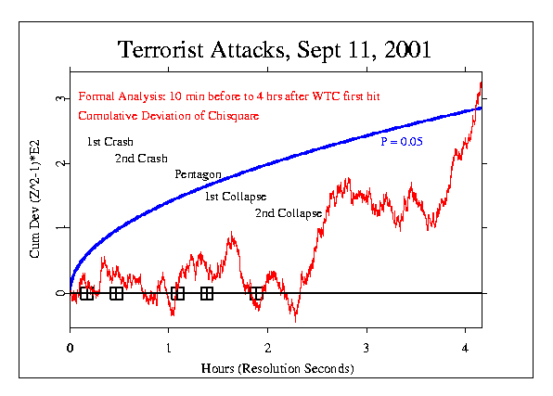
Figure 1: Cumulative deviation of Chi-square based on Stouffer Z across eggs for each second, from 08:35 to 12:45 EDT, September 11, 2001. The separate events of the terrorist attacks are marked with a rectangle on the line of zero deviation. A smooth parabolic curve shows the locus of a 5% probability against chance.

The formal test thus indicates a nominally significant departure from expectation but it is not especially persuasive by itself, given the enormity of the event. Moreover, the outcome clearly is dependent on a fortuitous specification of the timing in the formal hypothesis. It is therefore helpful to examine the larger context by looking at the behavior of the eggs before and after September 11. We find that while there is nothing unusual in the data from preceding days, the opposite is true following the attacks. During most of the 11th, 12th, and 13th there is a strong trend indicating correlated behavior among the eggs. This persistent deviation from random behavior appears to begin a little before the first crash, and it continues well beyond the time specified in the formal prediction. As it happens, a predicted aftermath of a few hours could not capture what appears in context to be a long-lasting aberration in the normally random flow of data.

Figure 2 shows the period from September 7th to 13th, with the time of the attacks on September 11 marked by a black rectangle. You can see that shortly before the terrorist attack, the wandering line takes on a strong trend representing a persistent departure from what is expected of random data. A small probability envelope inserted at that point provides a scale to indicate the extraordinary increase in non-random deviation. The slope of the graph beginning just before the the first WTC tower was hit and continuing for over two days, to noon on the 13th, is essentially linear and it is extreme. An informal estimate for the probability can be made from its slope, and lies between 0.003 and 0.0003 (suggesting an odds ratio on the order of 1000 to 1). If we extrapolate the anomalous trend, it begins at about 04:00 (08:00 GMT), several hours before the first World Trade Center tower was hit, and the total length of this persistent trend is about 56 hours. The mean number of days between segments with a slope like this, continuing for so long, is on the order of 2300 days, which is consistent with the 1000 to 1 odds ratio suggested by the slope itself.

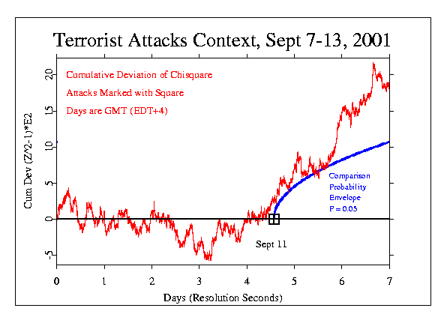
Figure 2: Cumulative deviation of Chi-square based on Stouffer Z across eggs for each second, from Sept. 6 to Sept. 13, 2001. Time of terrorist attacks is marked with a rectangle on the line of zero deviation. A smooth parabolic curve beginning at the time of the attacks provides a 5% probability comparison.

The multi-day perspective places the formal specification in a larger context, and we should also look at finer details. Figure 3 shows the raw odds against chance, second-by-second, for the squared Stouffer Z-scores (Chi-squares) for September 11. The maximum odds ratio, shown as a spike in the center of the graph, is equivalent to a Z-score of 4.81, and occurs at 10:12:47, EDT, not long after the first World Trade Center tower collapsed. A Z-score this large would appear by chance only once in about a million seconds (roughly two weeks). Thus it is not terribly unusual to find such a spike in our three-year database, but it is thought-provoking that one does occur within the brief time-span of the attacks, about an hour and 45 minutes. The ratio of this period to the mean time between spikes of this magnitude is 1/192, suggesting odds of this being just a chance occurrence of nearly 200 to 1.

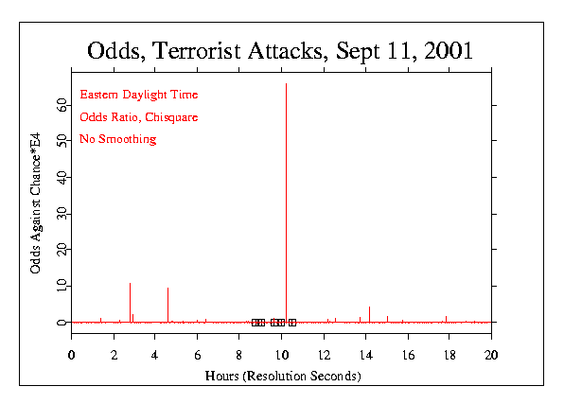
Figure 3: Odds ratios for the squared Stouffer Z across eggs for each second, on September 11, 2001. Times of the separate events in the terrorist attack are marked with rectangles on the zero line. The extreme spike occurs at 10:12:47 EDT.

Formal: Variance of the Data

Figure 4 shows the cumulative deviation of a measure of the variability of scores (variance) among the 37 eggs over the course of the day of September 11. It was generated as a test of Dean Radin's prediction that the variance would show strong fluctuations: "I'd predict something like ripples of high and low variance, as the emotional shocks continue to reverberate for days and weeks." Although this was only a partial specification it is effectively a prediction that the variance around the time of the disaster should deviate from expectation. I added the necessary specifications for a formal analysis, namely, a prediction of increased variance among the individual eggs at the beginning followed by low variance after the intensely disturbing events. The intent was to specify a degree of variability in the data that might correspond to the reactivity of people engaged by this uniquely powerful emotional imposition. In the event, as Figure 4 shows, the variance measure exhibits normal random fluctuation around the horizontal line of expectation until about three or four hours before the attack, and then a steep and persistent rise indicating a great excess of variance, continuing until about 11:00. Shortly thereafter, a long period begins during which the data show an equally precipitous decrease of variance.

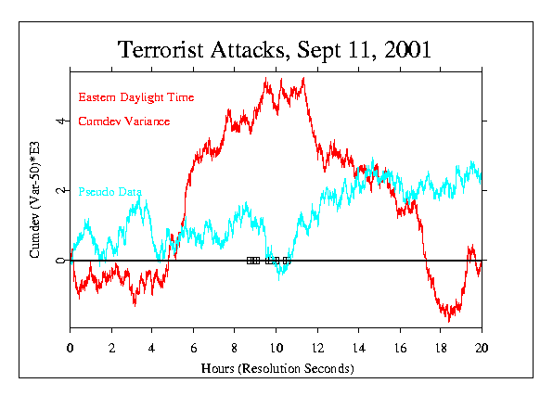
Figure 4: Cumulative deviation of variance across eggs for each second, on September 11, 2001. Times of the separate events in the terrorist attack are marked with rectangles on the zero line. The light gray curve labeled "Pseudo Data" shows a control calculation using a pseudo-random clone dataset for the day.

In this figure, the times on the X-axis are Eastern Daylight Time, allowing a direct assessment of the timing of the strong deviations. We note also that the distinctive shape of the graph is suggestive of a classic "head and shoulders" graph seen in stock market analysis of leading indicators (Walker, 2001). As in Figure 2, there is an indication that the effects registered for this horrendous event might have begun several hours prior to the first attack. For a visual indication of the likelihood that the data show merely a random fluctuation, a comparison can be made with the pseudo-data generated for September 11, 2001, and plotted in the same format. In contrast to the real data, there are no long-sustained periods of strong deviation in the algorithmically generated data. While it is not a rigorous test, this comparison with the pseudo-data indicates that the variance measure is unusual around the time of the attacks. It is difficult to make a direct calculation of probability for this analysis, but a conservative estimate is included in the formal database. It is based on assessing the fast rise and the fast fall of the variance measure surrounding the period of the attacks. The probability for each was calculated by extrapolation of the probability envelope as far (as many seconds) as would be needed to achieve the extreme rise or fall by chance, compared to the much shorter envelope that covers the time of the actual rise or fall. The resulting estimate is p = 0.096. Independent analyses by Bancel and Shoup suggest much a smaller probability.

Formal: Silent Prayer

After September 11th, innumerable calls for prayer were made. On the 14th of September there was a special emphasis on such collective spiritual moments, including major organized periods of silence in Europe and America. Doug Mast made a specific formal prediction for a deviation of the Chi-square over the time periods 10:00 to 10:03 GMT, corresponding to an organized mourning in Europe, and the time period 12:00 to 12:03 EDT (16:00 to 16:03 GMT) corresponding to the beginning of the Washington service and many organized mourning events in the Eastern US. Figure 5 is the resulting graph. The picture is compelling, I think, although it does not confirm the formal prediction. Instead, the trend shows a marginally significant decrease in the deviations of the egg data. The Chi-square is 150.68 on 180 degrees of freedom, with probability 0.95. The trend is steadily opposite to the usual (and specified) direction, but in an aesthetic sense it looks right - symbolic of the moment's contrast to the preceding days.

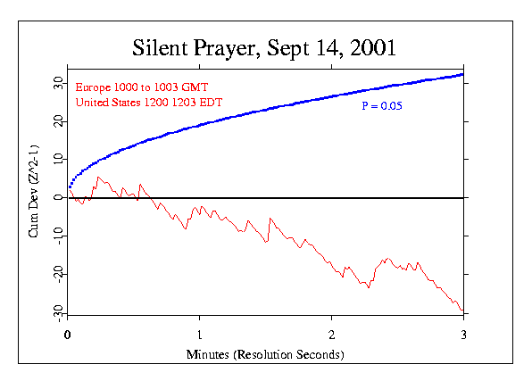
Figure 5: Cumulative deviation of Chi-square based on Stouffer Z across eggs for each second, for a three-minute period of silence on September 14, 2001. The plotted curve is a signal average of data from separate mourning ceremonies in Europe and Washington, DC. The smooth parabolic curve shows the locus of a 5% probability against chance.

Other formal predictions were made for events related to Sept. 11. These include the Sea to Shining See concert on Sept. 22, the Maharishi Effect Meditations during Sept. 23 to 27, the beginning of bombing in Afghanistan, Oct. 7, the Childrens' Pledge of Allegiance, Oct. 12, and an Internet-promoted, magical Binding Spell on Bin Laden, Oct. 15. All had positive deviations, with probabilities ranging from 0.29 to 0.04. Details may be found on the GCP Web site.

Exploratory Work by Independent Analysts

The formal hypothesis testing is augmented by exploratory analyses that add breadth and depth to the picture. Interpreted carefully, they can lead to much better understanding of the data, and at the very least, they can be a primary source for future analytical questions. Four individuals or teams have contributed independent assessments.

Dean Radin produced a variety of analyses of the September 11 events. One sample is presented here, and more can be found on the GCP Web site and in a paper addressing the effect of location of the eggs on the size of the deviations (Radin, 2001). Dean's treatment of the low-level data is different from the GCP's standard approach. Instead of a composite (Stouffer) Z across eggs, he calculates the Z-score per egg and sums the squared Z-scores and degrees of freedom across eggs. This responds to the variability among the eggs, while the standard analysis responds to correlation among the eggs. This approach mandates empirical instead of theoretical variance for the Z-score calculations. Dean uses sliding window smoothing or moving averages of the data across time. This can make interpretation difficult because the results depend very heavily on the choice of parameters such as the window width and centering. Because Dean also tries several sets of parameters to "optimize" the presentation, there is a form of data selection, so any probability or odds ratio that appears in the figures is an overstatement. It is, moreover, very difficult to compensate with the usual Bonferroni adjustment for multiple analysis because of the uncertain number of optimization analyses he does. Dean believes that work of this kind is legitimate in the context of good evidence from properly designed studies. I present the analyses here with the caveat that they have no evidentiary value, although as complements to formal analysis, they may lead to useful questions. I should add that Dean says everything he tried indicated unexpected structure in the data from September 11.

Figure 6 shows the 1-tailed odds ratios associated with moving average Z-scores calculated with a 6-hour sliding window for the data from Sept. 6 - 13. The Z-score variations show a particularly large excursion on the day of the attacks, corresponding to a peak of Z = 3.4 that then drops to Z = -3.1 over the next seven hours. A permutation analysis shows that the likelihood of finding a 6.5 sigma drop in Z-scores (based on a 6-hour sliding window) in one day, and within 8 hours or less is p = 0.002. Dean identifies the major spike in this graph as occurring at about 9:30 AM, Sept. 11. However, the algorithm that he used for the sliding window averages the data for the six hours preceding the plotted point. Thus, in terms of the original, unsmoothed data, the peak weight of the averaging actually occurs three hours earlier, at 06:30, somewhat more than two hours prior to the first WTC hit. The scale for the odds ratio magnitude is logarithmic, and the x-axis shows a "0" to mark the start of each day. To help assure that there was no mistake in the processing, the same calculations were made using algorithmically generated pseudo-random data instead of the real data from the truly random REGs located in countries all around the world. These "control" data are plotted in light gray in Figure 6, and though occasional peaks occur, they show only expected random variation. None of the pseudo-random excursions approaches the magnitude of the spike on September 11.

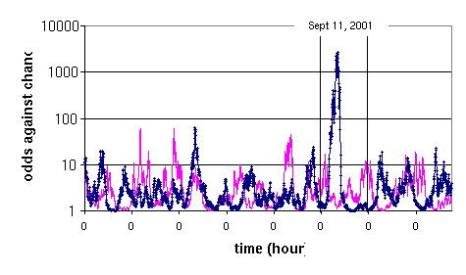
Figure 6: Odds ratios for the moving average of Z² across eggs with a six-hour smoothing window, from Sept.6 to 13, 2001. The extreme spike occurs at about 06:30 EDT on Sept. 11.The light gray curve shows the same calculation using the pseudo-random clone data for the Sept. 11. Figure by Dean Radin.

Peter Bancel has taken another perspective, focusing on the correlation of the eggs' output over time (Bancel, 2001). He describes his procedure as an autocorrelation of the second-by-second Stouffer Z's, using Fourier techniques. The resulting coefficients are normalized as the square root of the number of data points minus the autocorrelation lag. This yields a distribution of Z values that should be very closely N(0,1) distributed. The result is then visualized by taking the cumulative sum, as is done in the Chi-square figures. Figure 7 shows the four-hour period from 8:00 to 12:00 EDT on September 11. The large rise in the curve indicates an excess of correlation among the eggs during this time. It is evidently driven by a strong, persistent deviation in the average Z-score across eggs during the period from 9:50 to 11:50. This positive excursion of the Z-scores, as an isolated data set, has a two tailed p-value of 2 x 10⁻⁴ (z=3.71). So it is strong and it lasts for 1.9 hours. Placed in the context of a 24-hour data window a reasonable Bonferroni correction would put the p-value at 2.5 x 10⁻³. No other such block of data on the 11th shows any noteworthy trend. [Author note, this analysis and figure may be replaced by a more refined version.]

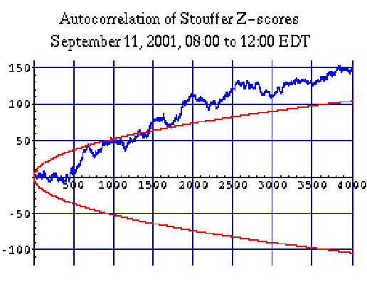
Figure 7: Cumulative sum of normalized autocorrelation coefficients for the second-by-second Stouffer Z-scores, using Fourier techniques. The time period is from 08:00 to 12:00 on September 11. The smooth curves show the 90% confidence interval. Figure by Peter Bancel.

Richard Shoup also has examined correlations over time, as well as other aspects of the GCP data. He uses the same treatment of the raw data as Radin, and hence is also looking at a measure of variability among the eggs. The analyses are particularly concerned with determining whether the September 11 data really are uniquely deviant in the context of long time-spans, and he concludes that they are, based on assessing data from July to October, 2001. One aspect of this effort addresses the question whether there is similar behavior across the eggs instead of the expected random relationship during the time of interest. Figure 8 is a sample from an extensive array of analyses by Shoup (Shoup, 2001). It shows the cumulative deviation of the moving average of Chi-squares calculated by summing the squared Z-scores per egg for each second. The smoothing window in this case is one hour, and the window is centered on the plotted point. The x-axis shows time in UTC, which was four hours later than New York time on September 11. This analysis assesses the generality of the large correlated increase in variance beginning around 8:00 UTC, by dividing the eggs into two groups in several different ways and plotting a separate curve for each group. The curves all show the same pattern, indicating strong correlation beginning at about 4:00 or 5:00 EDT and continuing for the entire day. In contrast, Shoup establishes that no such correlations are seen in arbitrarily selected "control" days.

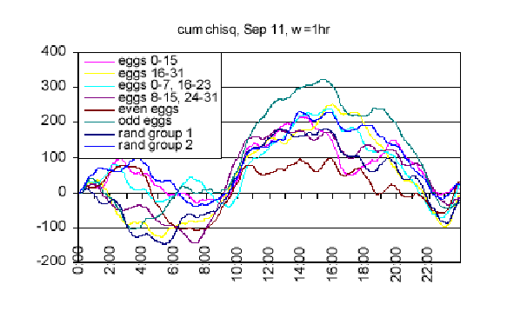
Figure 8: Cumulative deviation of the moving average of Chi-squares calculated by summing the squared Z-scores per egg for each second, using a smoothing window of one hour. Separate curves show several pair-wise comparisons of subgroups of the eggs to give a visual impression of their correlated anomalous deviation. Figure by Richard Shoup.

Ed May and James Spottiswoode took a severely critical look at the Sept. 11 results.(May & Spottiswoode, 2001). They began with an sophisticated examination of the nature of the data, and concluded that the GCP network of REGs does exactly what it is designed to do: it produces a continuing swath of truly random data, indistinguishable from theoretical expectation. They then selected certain of the formal and exploratory analyses to see whether they could find any way to discount them. They determined that their analysis of the primary formal hypothesis test confirmed mine, but went on to say that it was sullied by unclear hypothesis specification, that the specified time was fortuitous, and that the result was not very impressive anyway, given the magnitude of the global event. For the exploratory analysis, they focused on Dean Radin's sliding window approach and demonstrated that, as noted earlier, the result is dependent on the size of the window. They showed that apparently strong excursions or spikes can be made to disappear by judicious selection of the parameters.

Comprehensive Results

Although this paper is most concerned with the events of September 11, 2001, the formal predictions and analyses related to the terrorist attacks and the aftermath are only a small part of the GCP database. It is not feasible to provide details of other analyses, yet the September 11 results should be viewed within that context. In a sense, each individual prediction is another replication of the basic experiment, and the full database is a concatenation of the evidence for the general hypothesis. In other words, the overall evidence for the GCP hypothesis of a correlation of the EGG data with noteworthy events in the world comprises an accumulation of outcomes from a growing database of formally defined global events. At the end of October, 2001, 87 formal predictions had been made and analyzed over a three-year period. As is the case with any experiment using statistical measures, there is considerable variation, but about two thirds of the cases have a positive deviation, and 21% are independently significant at or beyond the 5% level. The composite probability that chance fluctuation can account for the total deviation from expectation is on the order of 2 parts in 10 million. The complete current database is summarized in tables and graphical displays on the GCP Web site at http://noosphere.princeton.edu/results.html. Most of the table entries contain a link to a complete description of the formal analysis for the event, and in many cases, further explorations and investigations that provide illuminating context for the formal prediction. For a graphical visualization, the individual results can be cumulated over time to provide a summary of the GCP experiment as a whole. Figure 9 shows the accumulating excess of the Chi-squares over their corresponding degrees of freedom for the 87 formal experiments. It culminates in a composite probability for the whole array of events that is 2.3 x 10⁻⁷. The dotted lines show probability envelopes for the cumulative deviation from chance expectation, which is plotted as the horizontal black line at zero deviation.

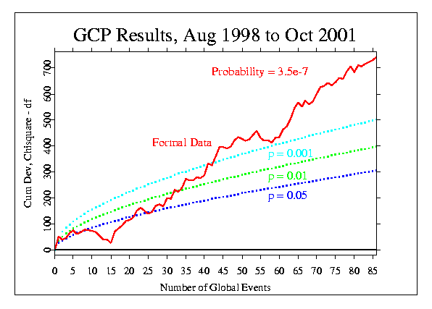
Figure 9: Overall results for 87 formal experiments over the past three years. The data curve shows the cumulative deviation of the individual "bottom line" Chi-squares representing the separate events from chance expectation, shown as the horizontal line at zero. Dotted curves show the 5%, 1%, and 0.1% confidence levels.

Discussion

I want to acknowledge that the best we can do is to report the data honestly and completely, because we do not have a theoretical understanding of the sort that must underlie robust interpretations. The accumulating evidence for an anomalous effect on the Global Consciousness Project's network of REG devices placed around the world is strong. There is a small but highly significant statistical deviation from theoretical expectation for a random distribution of REG outputs, integrated across all the active devices, and it is correlated with global events identified by experimenters without knowledge of the data or results. The effects are statistical in nature and are similar to what is seen in laboratory research and in field applications of the REG technology. The similarity raises the question why the effects are not stronger, given the large number of REG devices and the very large numbers of people who may be regarded as sources. In fact, there is no substantial evidence to support the assumption that multiple REGs will necessarily yield a compounded effect, or that multiple ostensible sources will increase effect sizes. For example, when larger effect sizes for pairs of participants have been reported, the attribution is not to the number of people but to a strongly "resonant" bonded relationship (Dunne, 1993), and in the FieldREG studies, there is no correlation of group size and effect size. The same general principle may apply to the data reported here, namely, the effects are dependent on the nature of the situation, including obviously subjective aspects, and not on simple physical parameters such as the location of detectors relative to the focus of a correlated event, the number of detectors, or the number of people involved. The potential for serious, objective assessment of questions like these is enormous given the continuous and growing database, the wide distribution of the REG network, and the unending variety of potentially instructive events.

In any case, the formal data from the EGG network definitely show an anomalous overall deviation that is consonant with our general hypothesis. Many of the individual events have results that, in addition to their technical, statistical contribution, also exhibit temporal patterns that, in the graphical displays are subjectively striking, perhaps even meaningful. Indeed, when we look for further insight from an aesthetic and subjective perspective to complement the hard-edged, scientific analyses, it is easy to find remarkable indicators that seem richly meaningful. Many examples from contextual and exploratory studies are presented in a special section of the GCP Web site (Nelson, 2001b). Of course we try hard to understand what the data say, and we are in a better position to explain the results than outsiders to the project. It is obviously important to identify the answers we give as speculative and provisional, but having said that, I would like to describe a speculation that appeals to me aesthetically. You can find more general discussion of alternatives and cautions on the GCP Web site.

One way to think of these startling correlations is to accept the possibility that the instruments have captured the reaction of an inchoate global consciousness. The network was built to do just that: to see whether we could gather evidence of a communal, shared mind in which we are participants even if we don't know it. Groups of people, including the group that is the whole world, have a place in consciousness space, and under special circumstances they - or we - become a stronger presence. Based on experimental evidence that both individuals and groups manifest something suggestive of a consciousness field, the GCP grew out of the realization that there could be a global consciousness capable of the same thing. Pursuing this speculation, we can envision an integrated global mind that is active and paying detectable attention to events that inspire strong coherence of attention and feeling among its constituents. Perhaps a useful image is an infant slowly developing an integrated awareness, but already capable of strong emotions in response to the enveloping comfort of cuddling or the intense discomfort of pain. The hypothesis we set out to test is that the REG devices we use may respond to the concerted effect of large numbers of people turning their attention in one direction, becoming deeply absorbed in one focus.

There are alternatives to an explanation of the deviations as an effect of communal consciousness, including that the experimenters themselves might be the source of anomalous effects. This is a viable hypothesis according to professional parapsychologists (White, 1976), and I accept the possibility that such an "experimenter effect" may contribute to the overall result. However, the characteristics of the individual events and their correlated outcomes strongly suggest that a broader and more comprehensive source is a major contributor. In the full database of formal and exploratory analyses, there are several instructive parallel cases. For example, my expectation, and that of my colleagues, for the Omagh bombing event in Northern Ireland was exactly the same as for the embassy bombings in Africa. They both were egregious travesties, and they both were the most prominent international news items when they occurred. Yet, the results for these two analyses are completely different; one showed a huge effect, the other none at all. The tragedy in Nicaragua in October 1998, from flooding and the collapse of the Casitas volcano, showed no response, contrary to our expectations; the bombing in Iraq produced no response, while that in Yugoslavia yielded a highly significant deviation. New Years Eve, which clearly meets the criteria for global interest as well as the experimenters' expectations, appears to produce quite different results each year, but in the three New Years we have assessed, the data around midnight are nonetheless unmistakably structured, not random.
Either of these models - communal consciousness or experimenter effect - begs for an interaction mechanism. One suggestion is to co-opt the qualities of field theory for a "consciousness field" that carries information (Nelson, 1999). This is not completely out of touch with models in physics, and might be formalized in terms of David Bohm's concept of "active information (Bohm, 1980). Other efforts to describe a mechanism that could produce the anomalous results in these experiments draw on the "observer" requirements of quantum theory. Although posed as an alternative to direct intervention of consciousness this seems more a displacement of its operation in time. The idea is that future observation collapses a superposition of possibilities into a state that may represent reality (Schmidt, 1982; Walker, 2000).

The terrible events of September 11 were a powerful magnet for our shared attention, and more than any event in the recent memory of the world they evoked extraordinary emotions of horror and fear and commiseration and dismay. The EGG network reacted in a powerful and evocative way. While there are viable alternative explanations, the anomalous correlation is not a mistake or a misreading. It can be interpreted as a clear, if indirect, confirmation of the hypothesis that the eggs' behavior is affected by global events and our reactions to them. This is startling in scientific terms because we do not have models that accommodate such an interpretation of the data. More important than the scientific interpretation, however, may be the question of meaning. What shall we learn, and what should we do in the face of compelling evidence that we may be part of a global consciousness? Of course, this is not a new idea or a novel question. The results from this scientific study are an apparent manifestation of the ancient idea that we are all interconnected, and that what we think and feel has effects on others, everywhere in the world. The implication of the GCP data reflecting our shock and dismay is in some sense quite obvious. It says that even insensate electronic random generators can see the effects of massive, shared emotion and attention, in this case a world-spanning, coherent reaction to the disaster. The deeds shocked us into a deeply shared communal recognition that this was a terrible manifestation of conditions in the world leading to hatred born of pain and despair. I think a global consciousness coalesced for a moment to say that the earth cannot support us in comfort as things now are. We are urged to recognize that we are not separate, completely independent individuals but, as our sages have said for millennia, we are interconnected and we are interdependent.

Conclusion

The GCP is an extension of laboratory REG experiments and nonintentional FieldREG experiments to a much larger domain, using a network of REG sampling nodes distributed around the world. The data from multiple, independent devices running in parallel, continuously over months and years, can be a rich resource for a variety of purposes, including correlation with special moments in time as described in this article. It may also be instructive to attempt correlations with other variables such as the geophysical and cosmological data that have shown some promise in psychophysiological and parapsychological research. Thus far, the main focus of the project has been on the question whether any evidence of a communal global consciousness can be seen. A definitive answer will require patient, continuing data collection combined with creative assessment techniques, but already it appears that by our simple measures there is robust evidence for anomalous departures of the data from expectation, correlated with global events.

Excellent technology, sound experimental design, rigorous analysis, and sophisticated controls exclude ordinary physical and environmental variations as spurious sources. Although the effects on the GCP data may well be modulated by experimenter expectations or other subjective influences, the most consistent correlate and hence the most likely source of the apparent effects is the relatively high coherence of widespread attention during events with a strong global focus. This report on the data from September 11th is the best description we can give of measurements and effects that are essentially mysterious. We do not know how the correlations that arise between electronic random event generators and human concerns come to be, and yet, the results of our analyses are unequivocal. The network responded as if the coherence and intensity of our common reaction created a sustained pulse of order in the random flow of numbers from our instruments. These patterns where there should be none look like reflections of our concentrated focus, as the riveting events drew us from our individual concerns and melded us into an extraordinary coherence. Maybe we became, briefly, a global consciousness.

Acknowledgments

The Global Consciousness Project would not exist except for the immense contributions of Greg Nelson and John Walker, who created the architecture and the sophisticated software. Paul Bethke ported the egg software to Windows thus broadening the network. Dean Radin and Dick Bierman contributed ideas and experience. Rick Berger helped to create an elegant Web site to make the project available to the public. The project also would not exist but for the commitment of time, resources, and good will from all the egg hosts. Our financial support comes from individuals including Charles Overby, Tony Cohen, Reinhilde Nelson, Michael Heany, Alexander Imich, Richard Adams, Richard Wallace, and Anonymous. The Institute of Noetic Sciences provides logistical support as a non-profit home for the project, and the Lifebridge Foundation has provided generous support for documentation of the GCP. Finally, there are very many friends of the EGG project whose good will, interest, and empathy open a spiritually mature niche in consciousness space.

References

* Three sources are in use: The PEAR portable REG, the Orion RNG, and the Mindsong Microreg. All three are designed for research applications and are widely used in laboratory experiments. They are subjected to calibration procedures based on large samples, typically a million or more trials, each the sum of 200 bits. An unbiased mean is guaranteed by hardware or software XOR logic.
* Data are collected continuously at all host sites over months and years. There are naturally some missing data from individual eggs due to hardware malfunctions, loss of electrical supply, and similar causes. Summary statistics are made from all valid data; no replacement values are used.
Radin, D. I., & Nelson, R. D. (1989). Evidence for consciousness-related anomalies in random physical systems. Foundations of Physics, 19, 1414 1499.
Jahn, R. G., Dunne, B. J., Nelson, R. D., Dobyns, Y. H., &Bradish, G. J. (1997). Correlations of random binary sequences with pre-stated operator intention: A review of a 12-year program. Journal of Scientific Exploration, 11, 345 367.
Nelson, R. D., Bradish, G. J., Dobyns, Y. H., Dunne, B. J, &Jahn, R. G. (1996). FieldREG anomalies in group situations. Journal of Scientific Exploration, 10, 111 141.
Nelson, R. D., Jahn, R. G., Dunne, B. J., Dobyns, Y. H., &Bradish, G. J. (1998a). FieldREG II: Consciousness field effects: Replications and explorations. Journal of Scientific Exploration, 12, 425 454.
Nelson, R., Boesch, H., Boller, E., Dobyns, Y., Houtkooper, J., Lettieri, A., Radin, D., Russek, L., Schwartz, G., & Wesch, J. (1998b). Global resonance of consciousness: Princess Diana and Mother Teresa. Electronic Journal for Anomalous Phenomena, eJAP. Retrieved Oct. 28, 2001 from the World Wide Web: http://www.psy.uva.nl/eJAP.
Nelson, R. D. (1998c). The Global Consciousness Project: Registering Coherence and Resonance in the World. Retrieved Oct. 28, 2001 from the World Wide Web: http://noosphere.princeton.edu
Nelson, R. D. (2001a), Correlation of Global Events with REG Date: An Internet-Based, Nonlocal Anomalies Experiment. The Journal of Parapsychology, Vol. 65, September 2001 (pp. 247-271)
Walker, J., (2001). Personal communication in reference to analysis of"leading indicators" as described in the classic text on stock market modeling by Edwards & Magee, 1954.
Radin, D. I. (2001). Global Consciousness Project Analysis for September 11, 2001. Retrieved Oct. 28, 2001 from the World Wide Web: http://noosphere.princeton.edu/dean/wtc0921.html
Bancel, P. (2001). Draft Report on Autocorrelations in GCP Data of September 11, 2001. Retrieved Oct. 28, 2001 from the World Wide Web: http://noosphere.princeton.edu/bancel/interegg.corr.html
Shoup, R. (2001). EGG Salad - Comments on the GCP EGG data for September 11, 2001, Retrieved November 6, 2001from the World Wide Web: http:// www. boundaryinstitute.org/ randomness.htm
May, E. and Spottiswoode, J. (2001). Memorandum for the record, re: Analysis of the Global Consciousness Project's data near the 11 September 2001 events. Retrieved Oct. 28, 2001 from the World Wide Web: http://noosphere.princeton.edu/papers/Sep1101.pdf
Dunne, B. J. (1993). Co-operator experiments with an REG device. In K. R. Rao (Ed.), Cultivating consciousness for enhancing human potential, wellness, and healing (pp. 149 163). Westport, CT: Praeger.
Nelson R. D. (2001b). Exploratory Studies: The Global Consciousness Project. Retrieved Oct. 28, 2001 from the World Wide Web: http://noosphere.princeton.edu/res.informal.html
White, R. (1976). The limits of experimenter influence on psi tests. Can any be set? Journal of the American Society for Psychical Research, 70, 333 370.
Nelson, R. D. (1999). "The Physical Basis of Intentional Healing Systems." Technical Report PEAR 99001, Princeton Engineering Anomalies Research, Princeton University, Princeton, NJ.
Bohm, D. (1980). Wholeness and the implicate order. Boston: Routledge & Kegan Paul.
Schmidt, H. (1982). Collapse of the state vector and psychokinetic effects. Foundations of Physics 12, pp. 565-581.
Walker, E. H. (2000). The Physics Of Consciousness: Boulder: Perseus Publishing.

